CI CD LAB EXPERIMENT-6

(BY: AMAN TYAGI)

Aim: Create a Pipeline using Jenkins file.

1. Start Jenkins
2. Create a pipeline from dashboard

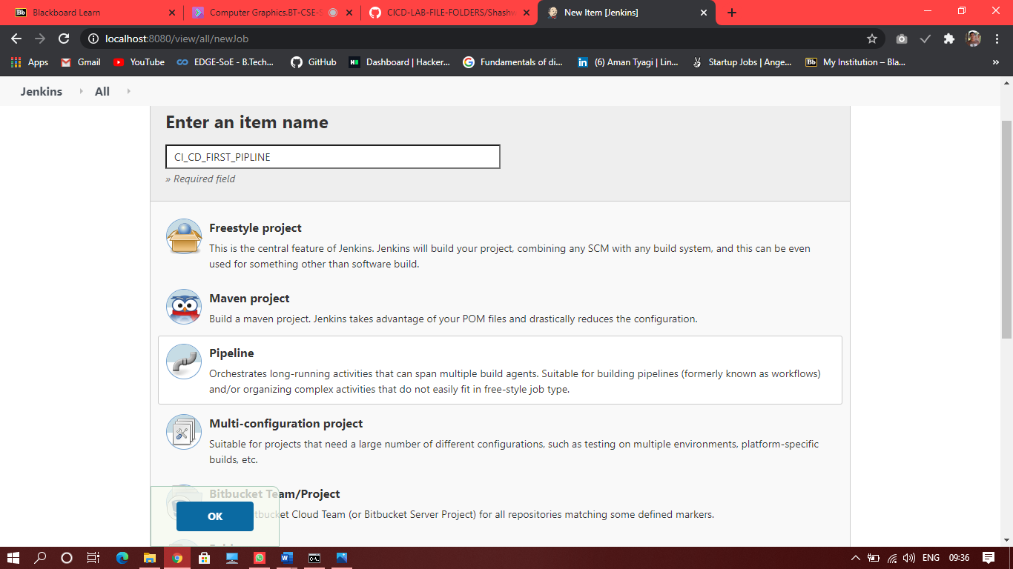

1. Now in the configuration settings in the Pipeline section select “Pipeline script from SCM” and enter the url of repo which have jenkins file and the project

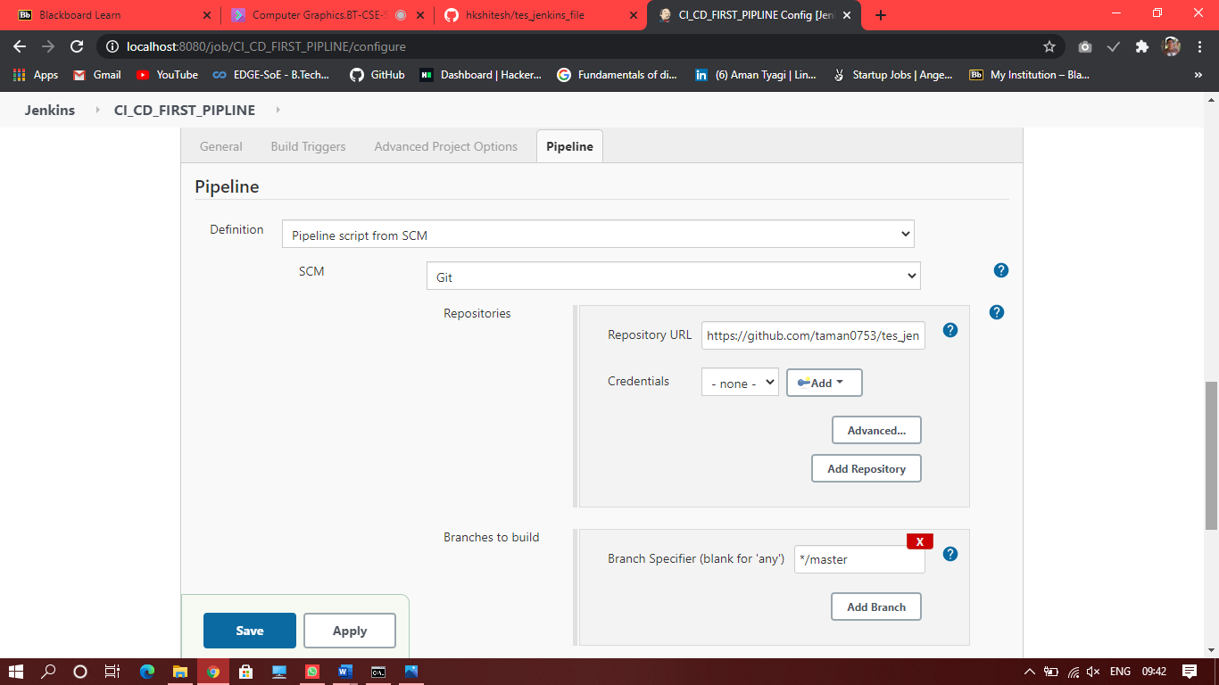

1. Now build the project and you will see success

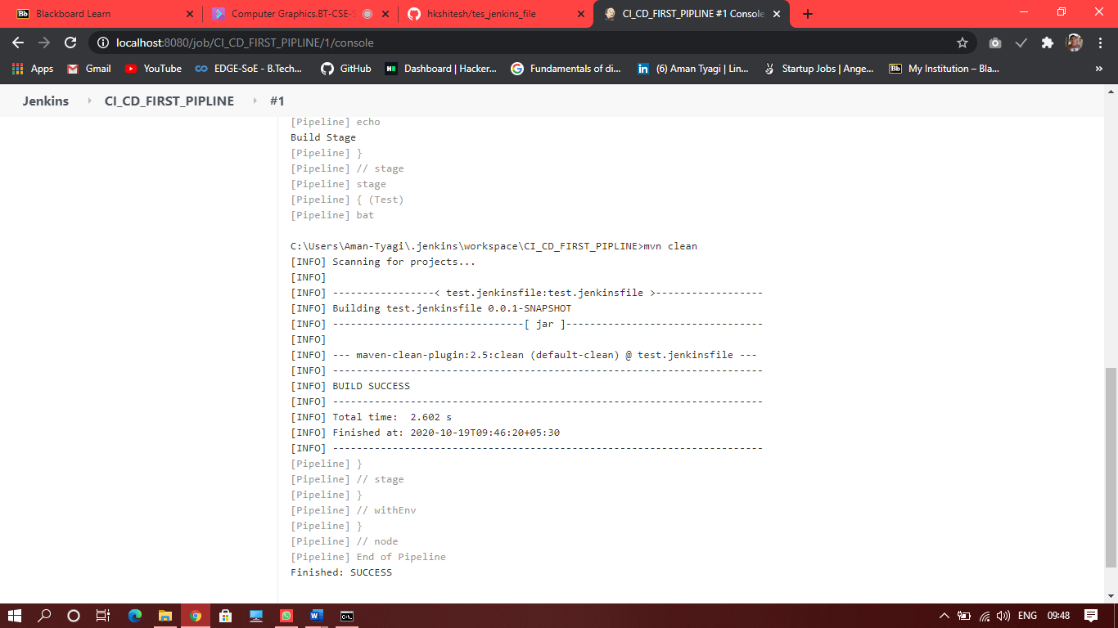

1. In the stage view you will be able to see the step executed mentioned in the Jenkins file

